How to Bend Conduit Pipe

Label Terms #1-6
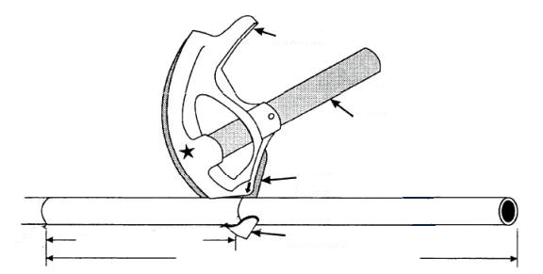

Describe the Steps for the Bending Process:

- Measure and mark the overall distance for the 90 degree bend
- Measure and mark the 5” take up deduction with an arrow line

- Step on the footrest bending towards the overall distance mark until the pipe is at a right angle (90 degree bend)

- Measure and mark the second overall distance using a square corner
- Cut conduit with a hacksaw

