Unit 4 Summative Assessment
Perform each transformation of the given figure.
1) A reflection over the x-axis 2) Translation up 4 units and left 2 units
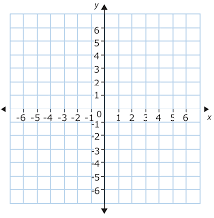

3) A 90 degree counterclockwise rotation 4) A dilation with a scale factor of 2/3
Describe the transformation occurring from the shaded to the unshaded figure; determine the scale factor if applicable.
5) 6)

7) 8)

Describe the series of transformations occurring from the unshaded figure to the shaded figure
9)

10)

11)

12) Perform the construction of a 120 degree counterclockwise rotation about the point “p”

. P
13) If a figure was rotated 270 degrees about the origin and then reflected over the x-axis, would it be in the original place it started? Would the transformed figure be congruent to the original?

14) If a figure was translated down 5 units, then left 7 units. The figure is then reflected over the y-axis. Will it be in the original place it started? Would the transformed figure be congruent to the original?

15) A figure is rotated 180 degrees about the origin and then dilated with a scale factor of 1.5. Would the transformed figure be congruent to the original? Explain.

16) Perform a dilation of the figure below though the origin. Is the line “AB” that runs through the origin parallel to the transformed line “A’B’”? Explain.

