New House Plot Design Activity
In this activity you will need to create a design for a house with the same floor plan, but rearranged to fit a different part of an apartment or a home development.
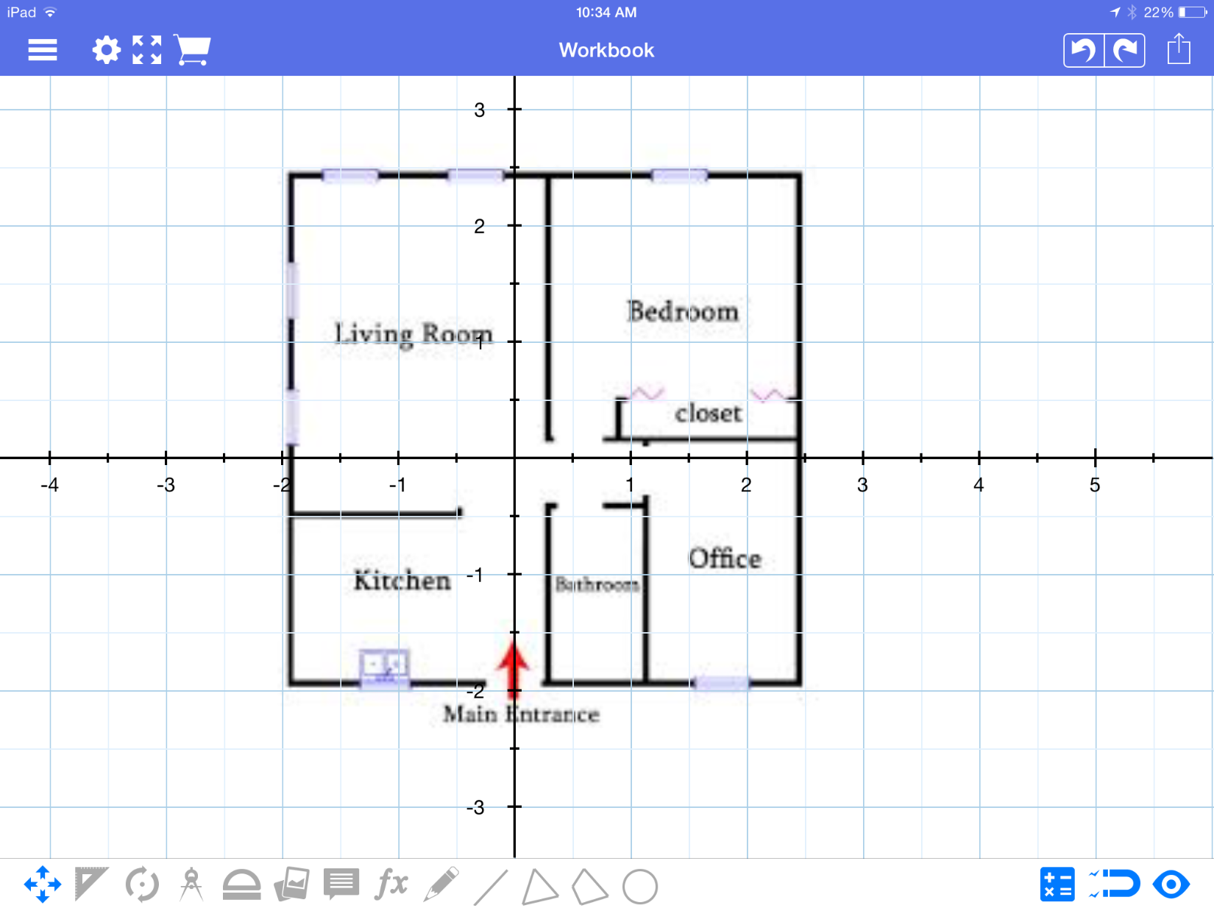

1) Mark all of the key points in the outline of the home; including the interior walls

2) List & label those key points below for future reference:

3) On the next few pages use your knowledge of transformations to determine the key points of the transformed home design.

4) Plot those key points and sketch the layout of the new home.

1) Take the given floor plan and sketch/label what the house would look like if the plan is rotated 90 degrees about the origin

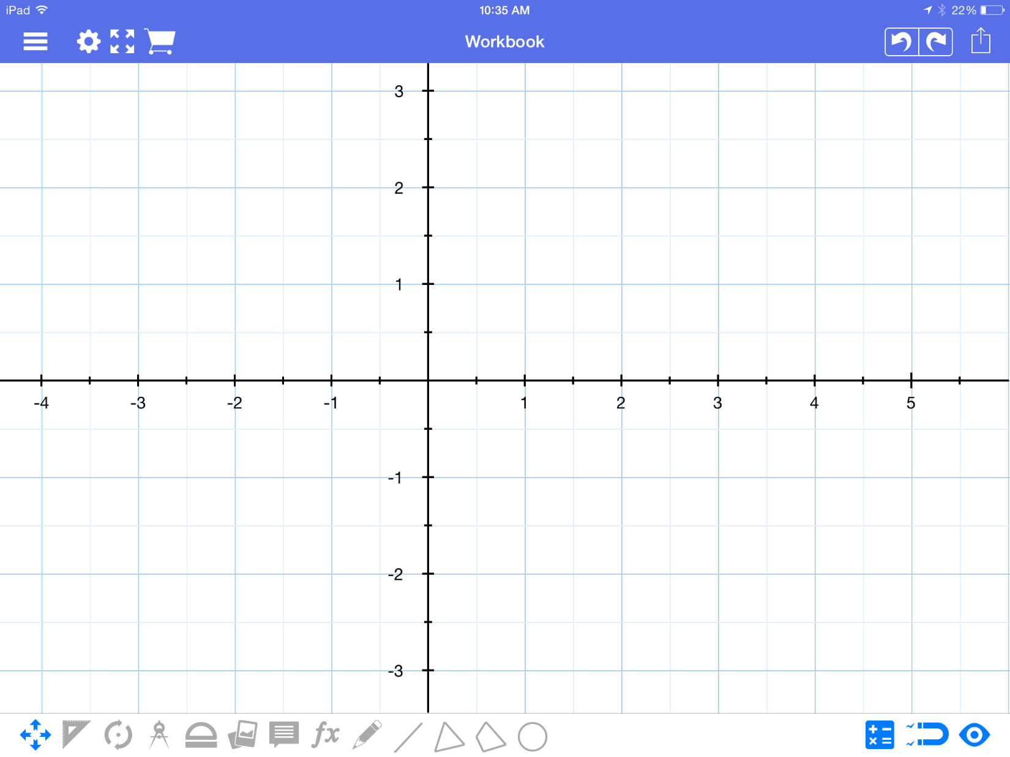

2) Take the given floor plan and sketch/label what the house would look like if the plan is rotated 180 degrees about the origin

3) Take the given floor plan and sketch/label what the house would look like if the plan is reflected East & West

4) Take the given floor plan and sketch/label what the house would look like if the plan rotated 270 degrees about the origin and then reflected North & South

