Unit 2 Summative Assessment
1) You need to lay a rectangular foundation for a house that is 45 feet by 60 feet. In order to make sure the foundation is square on the corners you need to find the length of the diagonal of the rectangle. Find the length of the diagonal to nearest tenth of a foot.

45 ft

60 ft

2) The picture below represents the roof of a house. You are able to find the diagonal length of the roof as well as the horizontal length of the house itself. What is the exact height of the roof in simplest radical form?

40 ft

32 ft

3) The distances for a 45 degree rolling off set pipe fitting are given below; if the valve of the pipe is ___________ inches, then how long do you need to cut the pipe so it will fit properly in the fitting? Give you answer to the nearest tenth.

4) What if the vertical and horizontal distances are doubled? How would that change the length of the pipe?

5) A pipe for a 60 degree rolling off set is 24 inches long. What is the vertical and horizontal lengths that this pipe can be used for?
24 in
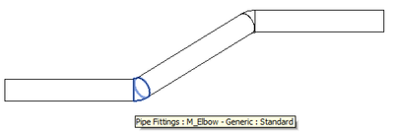

Find the volume of each figure below using the given measurements
6) Length = 15 feet, Width = 8 feet, Height = 7 feet

7) Radius = 12 in. & Height = 30 inches

8) Radius = 20 cm & Height = 45 cm
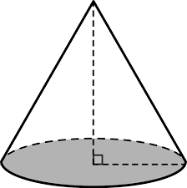
9)
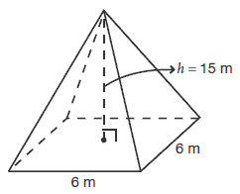

10)
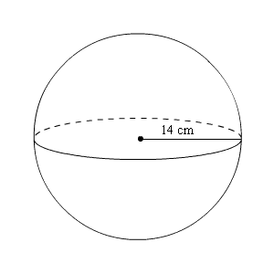
11) You want to install a closet into a home. The closet needs to have a height of 8 feet and a depth of 30 inches. To fit all of your clothes it needs to have a volume of 240 cubic feet. How wide should you build the closet?

12) A cylindrical water heater has a circumference of 36 inches and a height 6 feet. What should the dimensions be of a rectangular prism closet that could contain the water heater?

13) Use the diagram of a wall of a house below and the dimensions of a roll of insulation to determine how many rolls you would need to fill the wall with insulation?
Insulation Roll: 3.5 in. by 15 in. by 40 feet

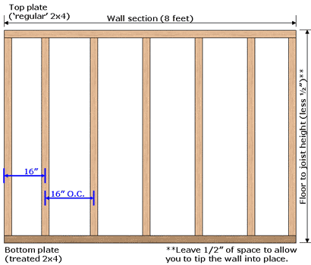

14) Suppose there are 12 other walls in the home with those dimensions and the insulation costs $16.99 per roll. How much will you spend to insulate the house?

15) Find the volume of the pyramid below:
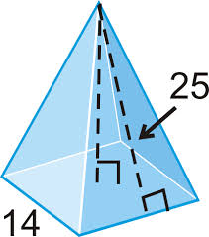

16) A mold for a concrete structure is shown below. If the total spent for concrete on the project was $1,200.00, then what was the cost of the concrete per cubic foot?
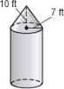

17) A contractor is building a cylindrical pool that is 6 feet deep and has a diameter that is 20 feet wide. What would happen to the volume of the pool if the dimensions are doubled?

18) If you were to slice a cone horizontally in half parallel to the base of the cone, then what shape would be formed on the base of the cut?

19) Now, what shape would be formed if the slice was made vertically through the top of the cone down the middle?

20) What 3D figure is generated by rotating a circle around a line?

21) What 3D figure is generated by rotating a right triangle around a line?

