Special Right Triangle Application Practice
1) To make a tile design you need to find the exact length of the diagonal of the original square. Use the given measurements to find the length of the diagonal.

2) On a Baseball diamond the distance between each base is 90 feet. What is the exact distance from home plate to second base? What is the estimated distance? How about from the pitchers mound (middle of home and second base)?
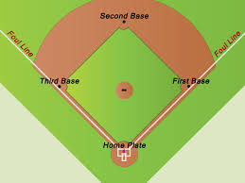

3) The diagonal of each square is given below, find the side lengths of each square.
- 15 cm -$6\sqrt{6}$

4) Find the area of an equilateral triangle with side lengths of 6 inches. $A= \frac{1}{2}bh$

5) You are in charge of designing a conveyer belt for a factory in which many of the pieces and parts need to fit exactly together. The conveyer belt rises at a 60 degree angle and will have a belt 20 feet long. How long and tall must the design be to fit this criteria?
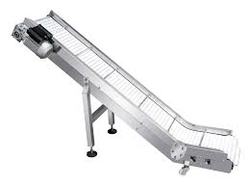

6) The picture below is of a roof truss of a house. The triangle in the middle is equilateral and is made with 4 foot long boards. How tall is the roof?
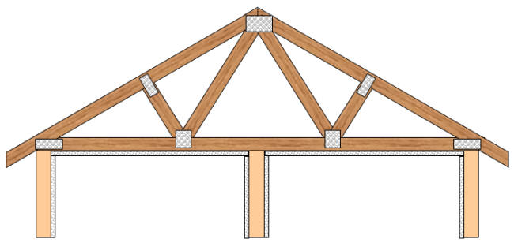

7) Using the same picture and your solution from #6 determine the length of the diagonal of the roof and the overall width of the house.

8) Use your ruler, protractor and what you know about 45,45,90 triangles to construct a 45,45, 90 triangle.

9) Use your ruler, protractor and what you know about 30,60,90 triangles to construct a 30,60, 90 triangle.

10) Use what you know about special right triangles to solve the triangle below.

