House Insulation Activity
Task 1: Take all of the measurements needed to find the total volume of space needed to insulate the house.

Total Volume of Insulation Space:

Task 2: Determine how many of each roll you should purchase for this task

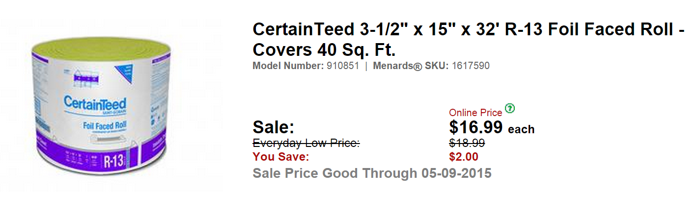
Total Amount:
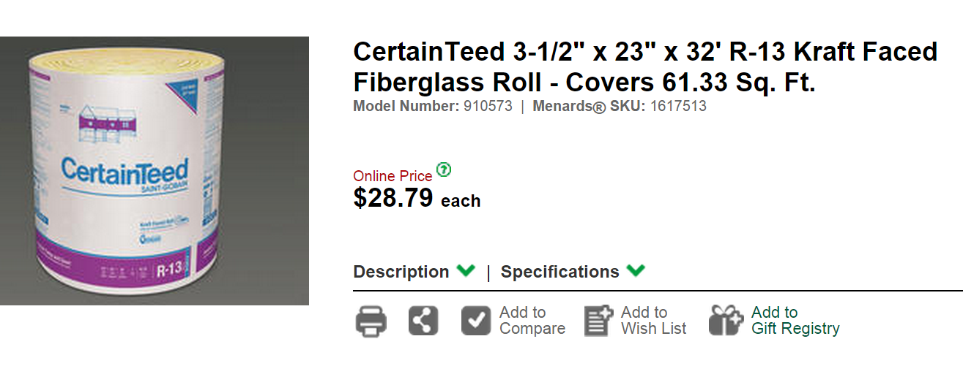

Total Amount:

Task 3: Determine how much it will cost to insulate the entire house.

