Unit 1 Test Area and similar shapes Name \_\_\_\_\_\_\_\_\_\_\_\_\_\_\_\_\_\_\_\_\_\_\_\_\_\_\_\_\_\_\_\_\_

Find the area of the following shapes

1. Find the area of each figure

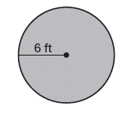

Area \_\_\_\_\_\_\_\_\_\_\_\_\_

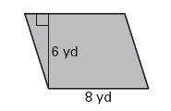

Area \_\_\_\_\_\_\_\_\_\_\_\_

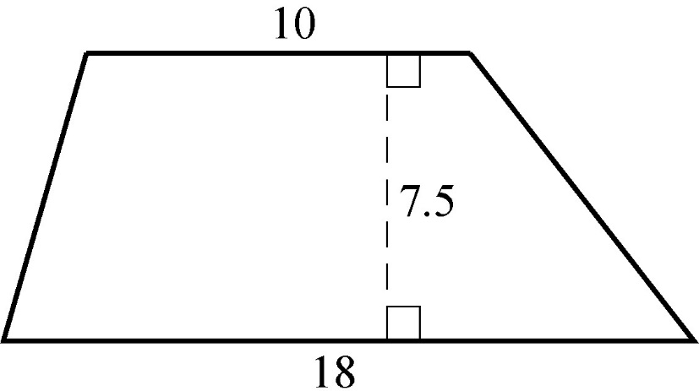

Area\_\_\_\_\_\_\_\_\_\_\_\_\_

Find the area of a regular pentagon with side length of 7 cm.



Area \_\_\_\_\_\_\_\_\_\_\_\_\_

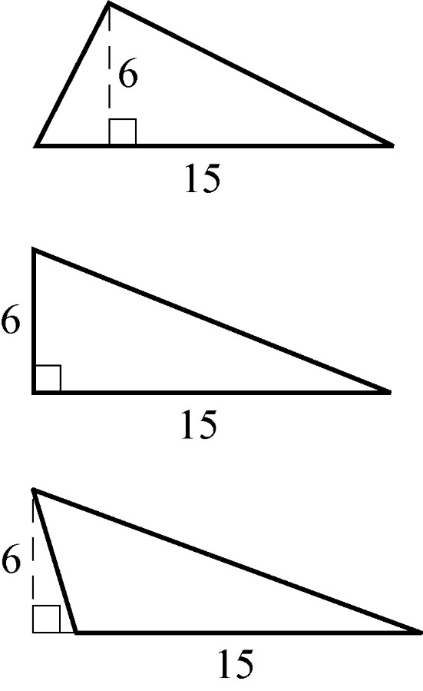

Area \_\_\_\_\_\_\_\_\_\_\_\_\_\_\_\_

Area \_\_\_\_\_\_

2. Find the missing heights

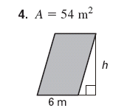 h =\_\_\_\_\_\_\_

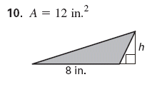h= \_\_\_

3. Explain two different ways you could find the area of the parallelogram.

Method 1 \_\_\_\_\_\_\_\_\_\_\_\_\_\_\_\_\_\_\_\_\_\_\_\_\_\_\_\_\_\_\_\_

\_\_\_\_\_\_\_\_\_\_\_\_\_\_\_\_\_\_\_\_\_\_\_\_\_\_\_\_\_\_\_\_\_\_\_\_\_\_\_\_\_\_\_

\_\_\_\_\_\_\_\_\_\_\_\_\_\_\_\_\_\_\_\_\_\_\_\_\_\_\_\_\_\_\_\_\_\_\_\_\_\_\_\_\_\_\_

\_\_\_\_\_\_\_\_\_\_\_\_\_\_\_\_\_\_\_\_\_\_\_\_\_\_\_\_\_\_\_\_\_\_\_\_\_\_\_\_\_\_\_

Method 2 \_\_\_\_\_\_\_\_\_\_\_\_\_\_\_\_\_\_\_\_\_\_\_\_\_\_\_\_\_\_\_\_

\_\_\_\_\_\_\_\_\_\_\_\_\_\_\_\_\_\_\_\_\_\_\_\_\_\_\_\_\_\_\_\_\_\_\_\_\_\_\_\_\_\_\_

\_\_\_\_\_\_\_\_\_\_\_\_\_\_\_\_\_\_\_\_\_\_\_\_\_\_\_\_\_\_\_\_\_\_\_\_\_\_\_\_\_\_\_

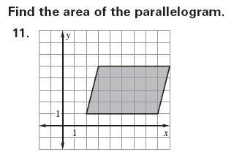

4. Write the name of each figure find the area of the base, lateral area, and total surface are of each figure.

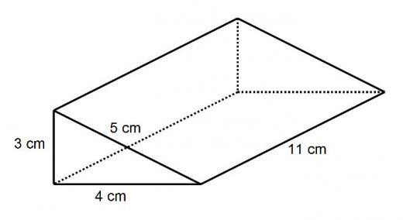

work

Name \_\_\_\_\_\_\_\_\_\_\_\_\_\_\_ Name \_\_\_\_\_\_\_\_\_\_\_\_\_\_\_ Name \_\_\_\_\_\_\_\_\_\_\_\_\_\_

Base \_\_\_\_\_\_\_\_\_\_\_\_\_\_\_ Base \_\_\_\_\_\_\_\_\_\_\_\_\_\_\_ Base \_\_\_\_\_\_\_\_\_\_\_\_\_\_

Lateral \_\_\_\_\_\_\_\_\_\_\_\_\_\_ Lateral \_\_\_\_\_\_\_\_\_\_\_\_\_\_ Lateral \_\_\_\_\_\_\_\_\_\_\_\_\_

Total \_\_\_\_\_\_\_\_\_\_\_\_\_\_ Total \_\_\_\_\_\_\_\_\_\_\_\_\_\_\_ Total \_\_\_\_\_\_\_\_\_\_\_\_\_

6 cm

8 cm

6 cm

8 cm

Name \_\_\_\_\_\_\_\_\_

Base \_\_\_\_\_\_\_\_\_

L.A. \_\_\_\_\_\_\_\_

Total \_\_\_\_\_\_\_\_

5. Yvette loves watching *Extreme Makeover: Home Edition* and has just been motivated to redecorate her room. She first wants to paint the walls her favorite color. Using the drawing below of Yvette’s room, find the amount of paint she will need to paint her room (1 pint of paint will cover 100 sq. ft.) ***Use what you already know and think in steps***

8ft.

13ft.

12ft.

4ft.

7ft.

3.5ft.

4.25ft.

6.

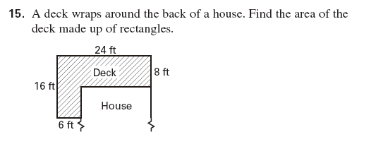

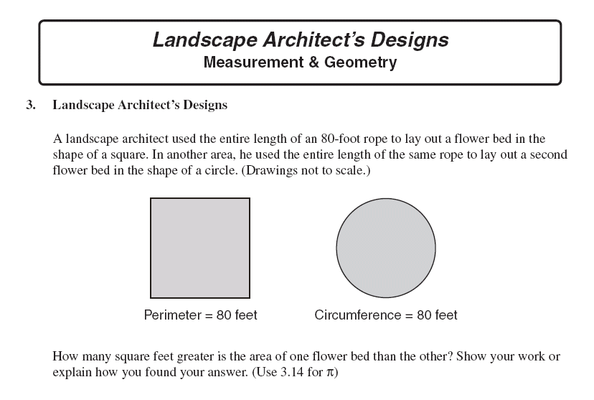

7

8.

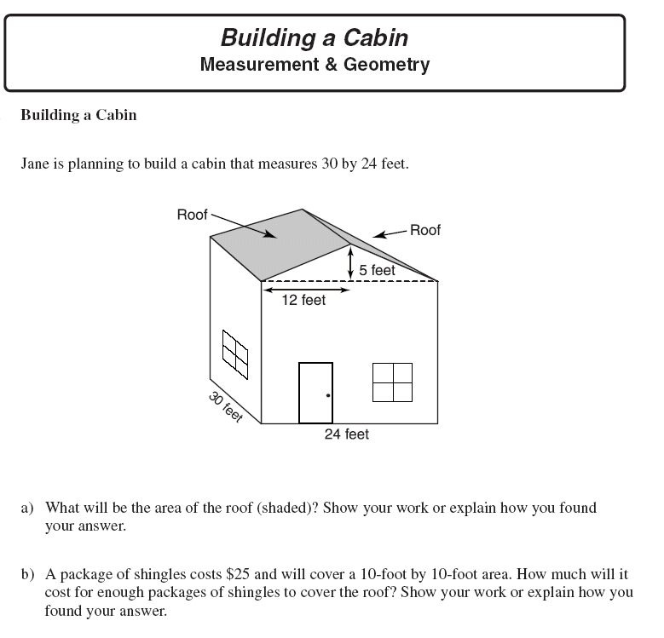

9-13 Multiple Choice Section

9.. Triangle PQR is similar to triangle DEF as shown.

E

6 cm

Q

4 cm

D 9 cm F

P 6 cm R

Which describes the relationship between the corresponding sides of the two triangles?

a)  b)  c)  d) 

10. A six-foot-tall person is standing next to a flagpole. The person is casting a shadow  feet in length, while the flagpole is casting a shadow 5 feet in length. How tall is the flagpole?

a) 30 ft b) 25 ft c) 20 ft d) 15 ft

11. ΔPQR is similar to ΔXYZ.

Y

Q

6

5

30

R

Z

P

10

X

What is the perimeter of ΔXYZ?

a) 21 cm b) 63 cm c) 105 cm d) 126 cm

12. The shadow cast by a one-foot ruler is 8 inches long. At the same time, the shadow cast by a pine tree is 24 feet long.

bd18253_

24 feet

What is the height, in feet, of the pine tree?

a) 3 feet b) 16 feet c) 36 feet d) 192 feet

8 inches

1 foot

13.. The angle of the roof on Kaya’s dollhouse is 56°. She built a scale model of the dollhouse with a scale ratio of 1 : 4. What is the measure of the angle of the roof of the model?

a) 14° b) 34° c) 56° d) 224°