Scale Factor Extra Practice
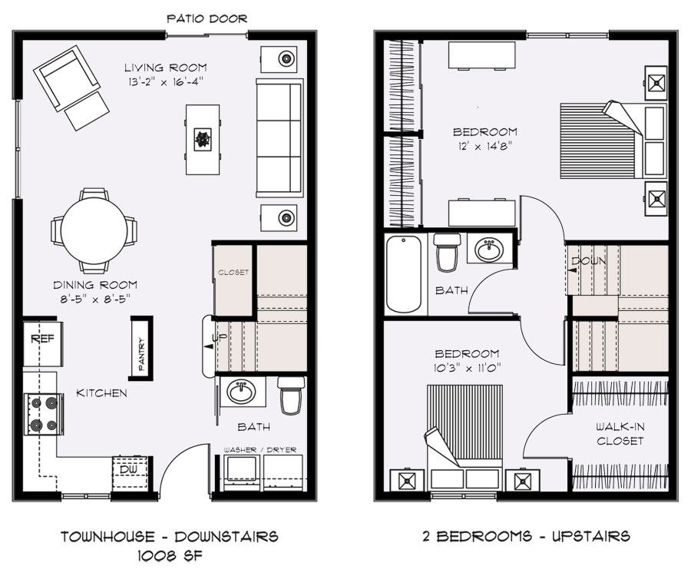

1) What is the scale factor from the drawing to actual size?

2) Use the scale factor to find the actual size of the beds in the house.

3) Use the scale factor to find the actual size of the couch in the living room.

4) What would the scale factor be to convert from the actual size to the scale drawing size?

5) Use that scale factor to find the drawing dimensions of a table that is 4.5 feet by 3 feet.

6) Suppose you want to install hardwood floors into the living room. The hardwood floors cost $4.99 per square foot. How much will it cost you to do this?

7) If a box of hardwood panels consists of 30 square feet, then how many boxes will you need?

8) You want to put carpet in the master bedroom. Carpet sells for $22.99 per square yard. How much will it cost you to carpet the master bedroom?

