2015-2016 | GEOMETRY IN CONTRUCTION | CONSTRUCTION PRINCIPLES
Website: _____________ | Facebook: ______________ | Twitter: _______________

Mr. Tristan Kumor Mr. Brian Collier
Room 133, Phone: 708.456.4242 ext. 1402 Room 133, Phone: 708.456.4242 ext. 1433
Email: tkumor@ridgenet.org Email: bcollier@ridgenet.org

Mr. Eric Lasky Ms. Sheri Costello
Room 133, Phone: 708.456.4242 ext. 1411 Room 115F, Phone: 708.456.4242 ext. 1243
Email: elasky@ridgenet.org Email: scostello@ridgenet.org

Welcome to Geometry in Construction! We look forward to working together with you to make this a successful year!

Course Description: Geometry in Construction is an interdisciplinary course that integrates Geometry and Construction topics through the building of a significant construction project. The purpose of the course is to provide students with a better understanding of both the Geometry and the Construction content through the combination of the academic and work-world contexts. The Geometry content matches that of the other Geometry courses taught in the Math Department, and prepares students for the subsequent Algebra 2 course. Students will be exposed to and gain hands-on experience in the following areas of construction: safety, framing, plumbing, electrical, roofing, windows, doors, and siding. Additional emphasis is given to teamwork, problem-solving, and the promotion of STEM education. This is a double-period course in which students earn credit for both Geometry and for Construction.
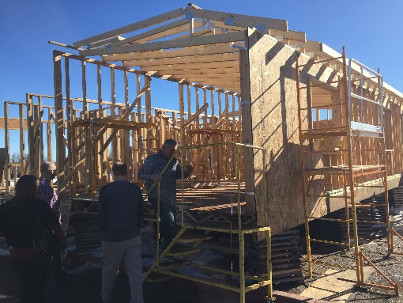
Supplies: EACH DAY you will be expected to bring…
- Your complete homework
- Your iPad fully charged
- A writing utensil (pen or pencil)
- A scientific calculator with sin and cos buttons
- Three ring binder with paper
Classroom Expectations:
WE EXPECT THAT YOU…
- Come to class on time, prepared, and ready to learn each day.
- Bring a pen or pencil, and a calculator to class each day.
- Work cooperatively, and contribute to a successful classroom community.
- Try your best. This means you will make an effort to complete every homework problem, and you will seek help if needed.
- Commit to doing your best work every day; stay attentive and stay focused
- Complete all activities in a professional manner.
- Leave the workplace clean at the end of class.
- Check the course website regularly.

YOU CAN EXPECT THAT WE…
- Come to class on time, prepared, and ready to teach each day.
- Work hard to make this class both interesting and challenging for you.
- Assign homework every day and check it often.
- Make ourselves available to help you during Rebel period.
- Keep the course website up-to-date with upcoming assignments.
Behavior, Attendance, and Tardies: Outlined in the school handbook. You are tardy if you are not in room 131 ready to work when the bell rings. To be successful in this class, you must come to class. Your construction grade is largely based on your work in class. If you are not in class, you must make up that work immediately.
Academic Conduct: Cheating and copying homework, quizzes, and tests will not be tolerated. Any individual cheating on an assignment will receive a zero on it. Your parents will be contacted and a referral will be sent to the dean. Copying homework assignments before class starts is cheating – both the copy-er and copy-ee will receive zeros.
Grading Scale:
A B C D F
90-100 80-89 70-79 60-69 0-59
Need help? Many resources are available if you are in need of additional assistance.
- We are available before school, after school and during Rebel period by appointment.
- Tutors are available through the management team as well as the math department.
____________________________________________________________________________________

GEOMETRY COURSE OUTLINE CONSTRUCTION COURSE OUTLINE

- Area
- Similarity
- Transformations
- Right Triangle Relationships
- Volume
- Right Triangle Trigonometry
- Law of Sines and Law of Cosines
- Quadrilateral and Parallel Lines
- Polygons and Ratios
- Triangle Congruence
- Circles
- Constructions
- Construction Planning
- Introduction to the Shop
- Introduction to this Year’s Home
- Framing Walls
- Laying out the Foundation
- Business of Construction
- Rough Plumbing
- Electrical Rough
- Drywall

PROJECTS
- Design a Logo
- Design
- LEED
- Trends in Residential Construction
- Construction Job Research
- Building a Shed: Design, Plan, and Estimate

GEOMETRY GRADING GUIDELINES
Homework: Homework is assigned daily. You make a reasonable effort to complete every assigned homework problem. It is unreasonable for you to arrive in class with problems missing from your homework. A reasonable effort includes contacting classmates at night for help if you cannot begin a solution to a problem. It should take between 30 and 45 minutes. Homework is due at the start of each class. Failure to do the homework will result in a loss of construction time.
Quizzes: Quizzes will take place at least once a week. Some will be announced and others will not. Each quiz will cover material featured in the homework since the last quiz. Quizzes are given frequently.
Tests: Tests will be given at the end of each unit and are cumulative. They will be more comprehensive and challenging than quizzes. The grading scale will reflect the difficulty of the tests. I award partial credit for correct mathematical work contained within a complete solution, provided that the work is shown in an orderly, coherent manner.

CONSTRUCTION GRADING GUIDELINES
Course Evaluation: The grade that you earn will reflect your performance on the written and practical exams, lab assignments, and projects.

Final Note…
We believe that you can be successful in anything that you set your mind to, even mathematics! Mathematics requires you to actively learn by always doing homework and asking questions. Practicing your skills, old and new, every day will make you a much stronger Geometry in Construction student. Please see us for any of your Geometry in Construction concerns. We will be happy to help you!

If your parent or guardian send an e-mail or handwritten note to us by September 1st, we will award you with a free pass on one quiz.
- In the subject of the e-mail or handwritten note, write your child’s name.
- In the body of the e-mail or handwritten note, complete the following statement: Something about my child that could help you when instructing him/her in the classroom is _____________.

